A BRIEF HISTORY OF THE CHAKRAS

Pam Gorst

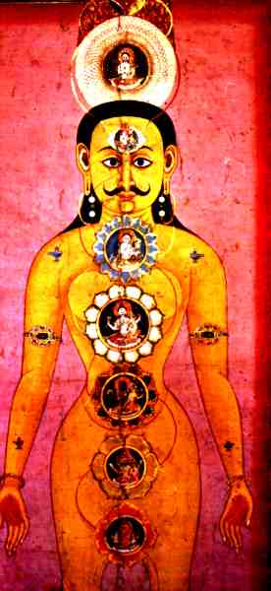
Have you ever wondered about the chakra tradition, the interpretations of the chakras when mentioned in your yoga class, or why they are associated with the rainbow colours during visualisations? If so, then read on, you may very well be surprised.

The first known mention of chakras appeared in a number of early Upanishads around 7-800 BCE. Later Upanishads around 200 BCE – 200 CE, namely Shri Jabala Darshana Upanishad, Cudamini Upanishad, Yoga-Shikka Upanishad and Shandila Upanishad, made reference to tantric concepts such as chakras and mantras, and gave both locations and symbolism. In the 10th century, the Gorakshashatakam, written by Guru Goraknath, gave information on the powers of awakening and meditating on the chakras.

During the 16th century Swami Purananda wrote the Shri-Tattva-Cintamini, the 6th chapter of which is called the Sat-Cakra-Nirupana (investigation of the six centres), including descriptions and practices to activate the chakras, as well as the powers attributed to each chakra and the movement of kundalini in piercing them on its upward journey. This work was translated in the early part of the 20th century by Sir John Woodroofe (alias Arthur Avalon) entitled “The Serpent Power”, first published in 1919. It is not an easy read, but is probably the foremost text on chakras and kundalini. Around this period the Theosophical movement were active, and introduced chakras to the West through the works of Alice Bailey, whose writings over a 30 years period were the result of “telepathic communication with the Tibetan master Djwhal Khul”¹; and the publication of C.W. Leadbeater’s “The Chakras”, based around the tradition of Madam Blavatsky, as well as his own experiences and interpretations.

Leadbeater took the traditional concepts from tantra and Indian religious culture, but interpreted them more freely, no doubt to suit the sensibilities of the time. His influence cannot be denied, as he made a number of observations which have been latched onto by other “Theosophical and New Age writers and clairvoyants, although very few actually give him credit for being the first to come up with these ideas”.³ The illustrations in his book “The Chakras” are particularly beautiful, but reflect what the chakras appear to be from a clairvoyant perspective. In traditional tantra, particularly that in Tibet, the chakras are created as mental exercises. What is now implied is “that the chakras have an independent objective existence in the subtle bodies that can be perceived by anyone who has developed the appropriate faculities”.⁴ Clairvoyantly, chakras are seen as vortices of energy within the auric field, whereas traditionally “the chakras are subtle centres of consciousness, but have no energy-status of their own”.⁵ Leadbeater was the first to suggested that chakras were transformers of energy or consciousness, which has now become a standard interpretation.
Thirty years ago few had heard of the chakras, whereas now it has come into common usage, with a number of set concepts that seem to be embedded into the modern yogic mind. Christopher Hills published a book entitled “Nuclear Evolution” in the early 70’s, which probably did as much as Leadbeater to influence Western thinking about the chakras. One of the most significant areas Hills was responsible for was the relationship of the chakras to the spectrum colours, which until that time had not been linked. The other contribution he made was relating the chakras to personality types and has now become mainstream chakras analysis in New Age and yogic circles. Neither this nor the rainbow colours relate to the original intention of the tantric chakra scheme, but now seems to be an accepted part of their interpretation.

Over the thousand or so years of this esoteric tradition and much secret knowledge relating to chakras, there has been a shift in perception as this has been shared with the West. The chakra system is seen as a gateway to help us understand ourselves not just as physical beings but as spiritual ones. The nature of the original symbolism is not necessarily relevant to us now, and has evolved to provide meanings that we can understand and access. Our need to verify and substantiate the reality of the chakras will no doubt continue into the 21st century, with scientific evidence proving or disproving their existence.
Finally, I would like to pose the question: should we accept the New Age interpretations of the chakras without question, or return to the traditions that have stood the test of time?

ACKNOWLEDGEMENT
Terri Hilder, DCT
REFERENCES
¹ Ozaniec, Naomi, The Elements of the Chakras, 1990, p 6
²⁻⁶ ww/kheper.net/topics/chakras/chakras-TS.htm (accessed Aug 03)
BIBLIOGRAPHY
Leadbeater, C.W. The Chakras, Theosophical Publishing House, 1927
Avalon, Arthur, The Serpent Power, Dover Publications, 1974
Feuerstein, Georg, Encyclopedic Dictionary of Yoga, Unwin Paperbacks, 1990
www.annikalangle.com/chakras.htm (accessed Aug 03)

